ROUTE 53

**Open the Route 53 Console from your AWS Console**

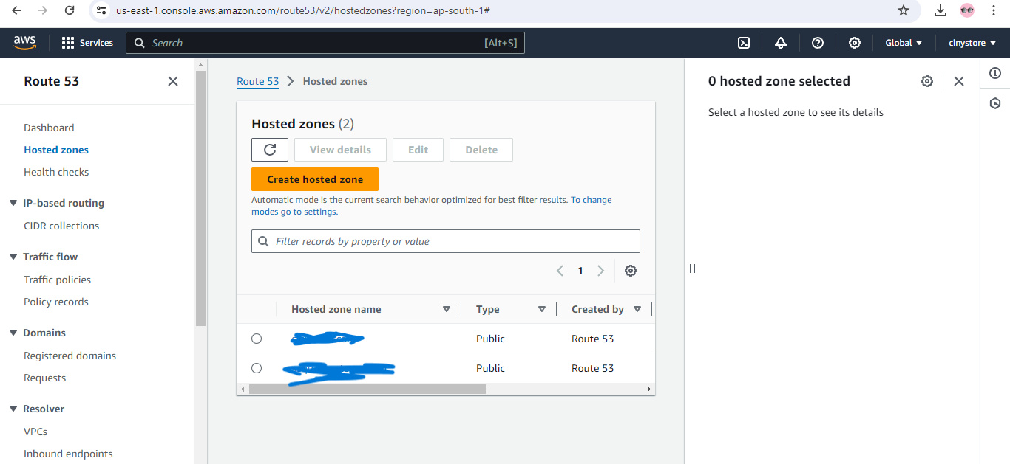

**Click on Create hosted zone**

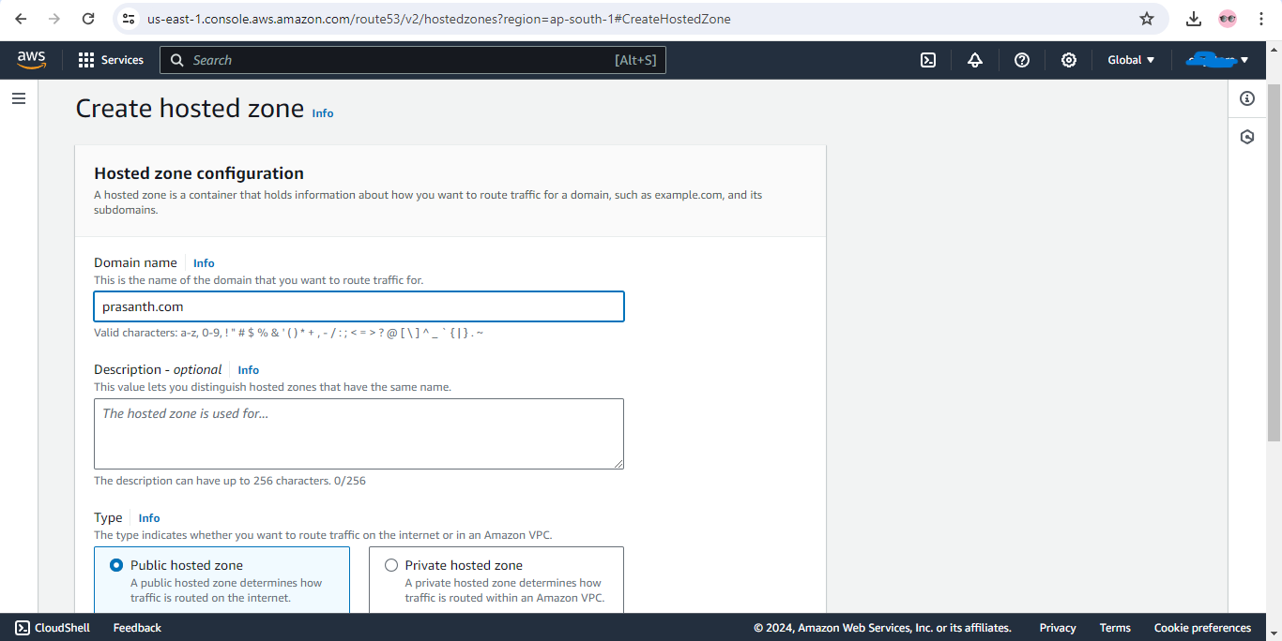

Give the domain name as per requirement **(example 🡪 prasanth.com, prasanth.in, prasanth.net etc.,)** and keep the zone as public hosted zone.

After completing at the right corner click on Create Hosted Zone

Then you will see the hosted zone was created as given domain name.

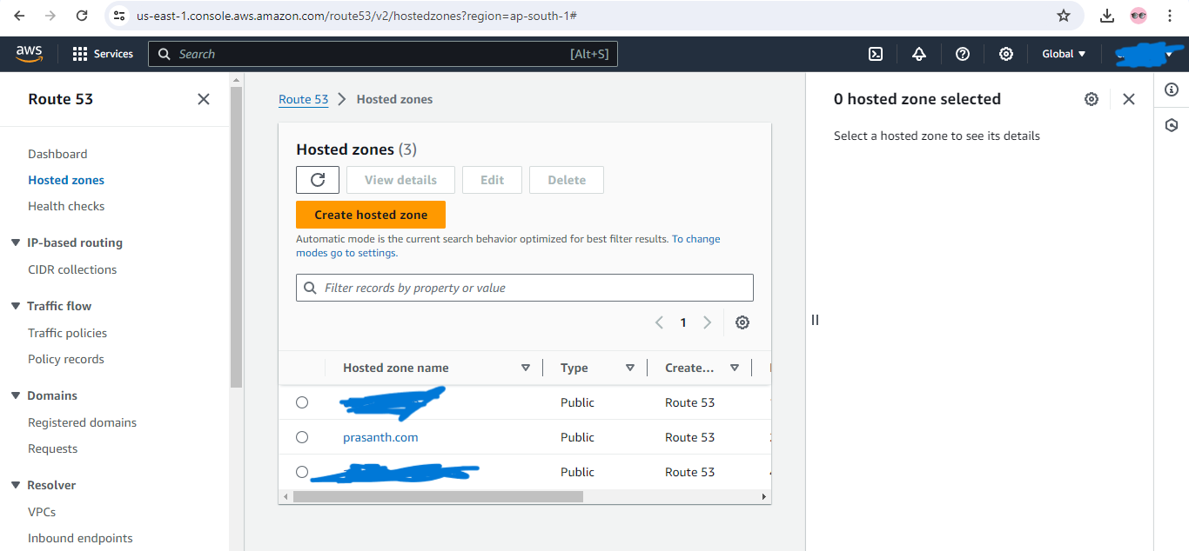

Click on Hosted Zone name (prasanth.com) you will see a NS and SOA

Route 53 automatically creates the Name Server (NS) and Start of Authority (SOA) records for the hosted zones.

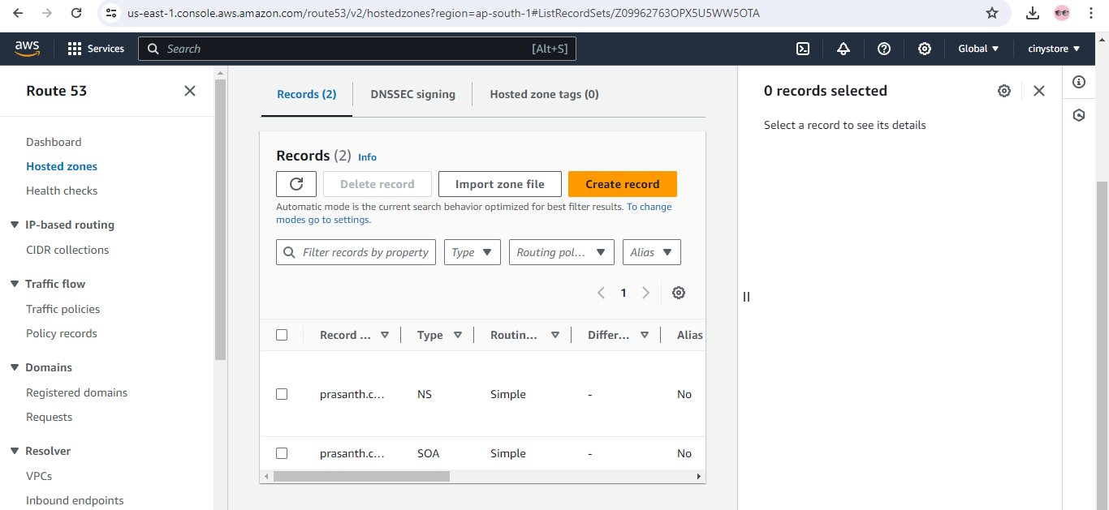

My domain is prasanth.com I have to create a A Record set for [www.prasanth.com](http://www.prasanth.com) by pointing to the public IP address where Server was hosted .

A Record set for [prasanth.com](http://www.prasanth.com) by pointing to the public ip address where Server was hosted .

Note: An A record maps a domain to the physical IP address of the computer hosting that domain. Internet traffic uses the A record to find the computer hosting your domain's DNS settings. The value of an A record is always an IP address